**Karen’s Company Painting Estimator Program**

***Zeke Van Dehy***

***9/24/2020***

## Project Name: Karen’s Company Paint Estimating Program

## Project Overview:

For a small business who needs a practical and adaptable estimating program, *Karen’s Company Painting Estimator Program* (also known as PEP) is a web-based application that provides an appealing estimator interface, estimating logic, and customer relations/communication services. Unlike other estimating programs, the *Karen’s Company Painting Estimator Program* is specific to *Karen’s Company Inc’s* estimating logic and easy to learn for new salespeople/estimators. Karen’s Company employees can use the web-application while conducting a bid at a customer’s home. Once the estimator has completed the bid, the program allows them to send a proposal/estimate and contract for the customer to review and sign. The website will contain a login process for Karen’s Company employees, an interactive form for users to enter details of a bid, logic to create a proposal using input data, and mechanisms for providing customers with documentation of the bid/proposal and contract. An important aspect of the application will be the ability to create cost and time estimates based on the entered data. Part of this logic is “production rates” which evaluates the difficulty/time required to paint a space depending on the details provided in the form. Production rates depend on the height and complexity of a room, and each room should be provided a production rate difficulty (standard, complex, or simple).

## Client Information:

The clients are Karen & Jeff Van Dehy

Karen is the owner of *Karen’s Company Inc.* and Jeff is the CFO

Karen Van Dehy: [karen@karenscompany.com](mailto:karen@karenscompany.com)

Jeff Van Dehy: [jvandehy@gmail.com](mailto:jvandehy@gmail.com)

## Site Map: <https://www.gloomaps.com/flWYMsyaJQ>

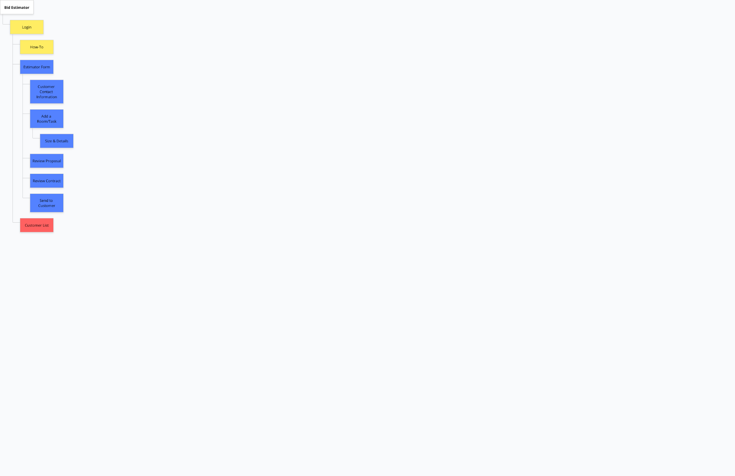

## Page Design [one section needed for each page/sub-page]:

**Estimator Home Page**

This page is the home page of the application. It allows users to login (or at least select which employee they are) and start a new bid. Beyond the minimum viable product, this page would include short descriptions of and links to the following pages: Customer History and How-To. The purpose of the page is to be a minimal jumping-off point for an estimator/employee to indicate that they want to begin creating a new estimate for a customer. The users of this page are Karen’s Company Estimators/employees. There will be either a dropdown of current Karen’s Company Estimators or 2 text inputs to enter login credentials. Then there will be a submission button labelled “Start a Bid” which will launch the General Information Page and prefill some of the inputs in the General Information form with the selected employee’s information.

**General Information Page**

This page is the first form in every bid/form process. It needs to contain information like Customer Name, address, contact information, dates, etc. The purpose of this page is for the Estimator to quickly enter basic (but essential) information about the customer and their home. Usually, the estimator will be the user, but on occasion the estimator could ask the customer to enter the information (and physically hand them the device - usually some form of tablet). This is important to note so that any random person should be able to fill out this page of the form. Some of these fields will need validation (phone, email). Some of the fields will be optional. Once the user has completed entering the information, they should be able to continue to the next stage of the process by clicking a “Next” button. This will launch the “Add a Space Type” page.

**Add a Space Type** **Page**

This step of the form should be simple for a user to navigate and the user should not spend a lot of time here. The purpose of the page is to allow the estimator to select the next space type that they want to include in the bid. Examples of a Space Type are “Bedroom”, “Bathroom”, “Kitchen”, etc. The audience of the page is the estimator. The content will be a grid of images and labels for all the possible space types that an estimator could select. These images with overlaying labels will be selectable by the user (only one selected at a time). Once a space type is selected, a “Enter Details” button will become enabled which will launch the user to the next step in the process. Users will be returned to this page once they have completed entering the detailed information for a room. Thus, this page will also include a button that links to the Review Proposal Page.

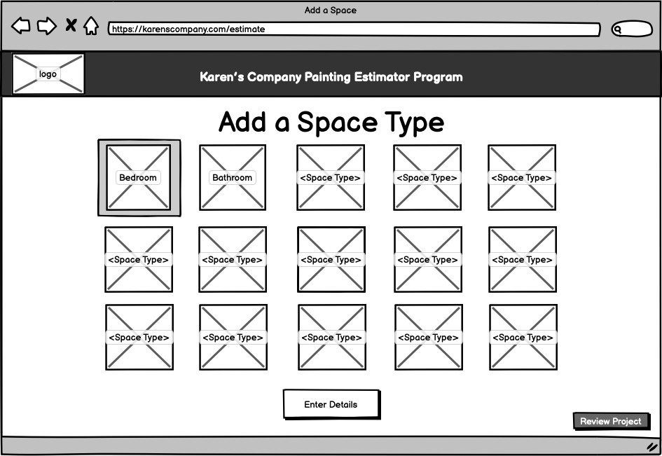

**Details Page**

The purpose of this page is for the user to enter all of the relevant information regarding a space that is to be included in the bid. Again, the user is the Karen’s Company estimator/employee. Karen’s Company conducts bids by first visiting with the customer and exploring the home, and then going through again and doing the “count & measure” portion of the bid. This page is where an estimator needs to input the “count & measure” information. The process of “count & measure” is simple: count jobs like painting doors & windows, and measure items like the dimensions of the room. However, there are many “jobs” that could be completed in each room so it is essential that this page contains an appropriate amount of content. There shouldn’t be so many inputs that a user becomes overwhelmed, but there should be enough that the user doesn’t have to navigate between many pages if they forgot to include an input. The clients and I have discussed separating the jobs into categories such as Walls, Doors, Windows, and Miscellaneous in order to separate input information. Each of these categories will be made available by pressing on the desired menu-button that will be in a menu-bar at the top of the page. Without redirecting to a new page, the user will be shown the input information for the selected category. Not every customer/home is the same, so most inputs will be optional. However, there is crucial logic required where some inputs require other fields to have values and this information needs to be validated. When a user has completed entering the necessary information, they can “Save <Space Type>” which will take them back to the “Add a Space Type” page.

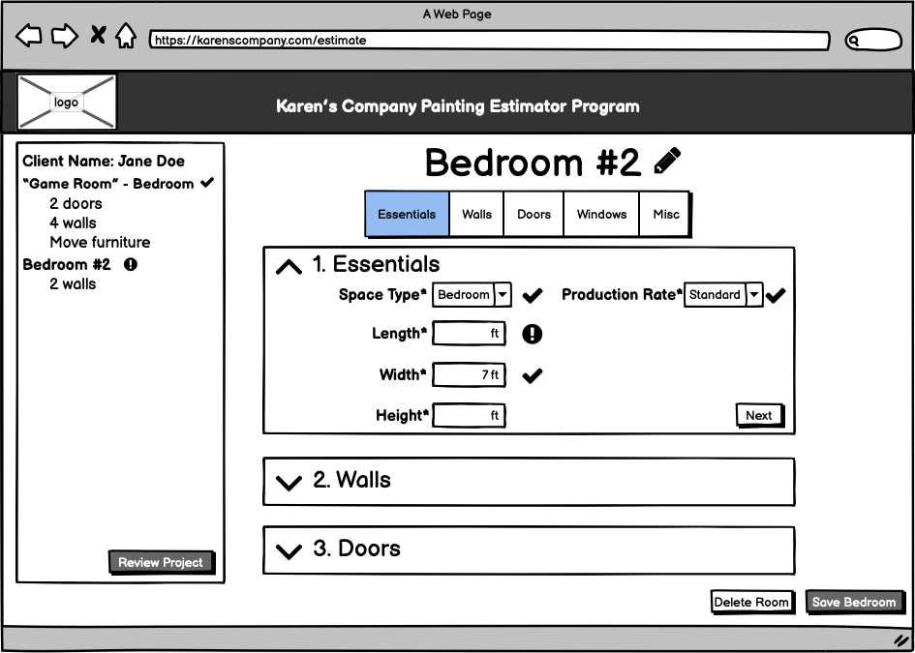

For reference, the figure below shows the current tool that Karen’s Company uses to input details for a room. All of the jobs in this example should be located in one of the categories found in the Details page. Also, some jobs include additional information like “# Coats”. The details page must reflect all of the functionality contained in the example below, in addition to improved functionality like Production Rates.

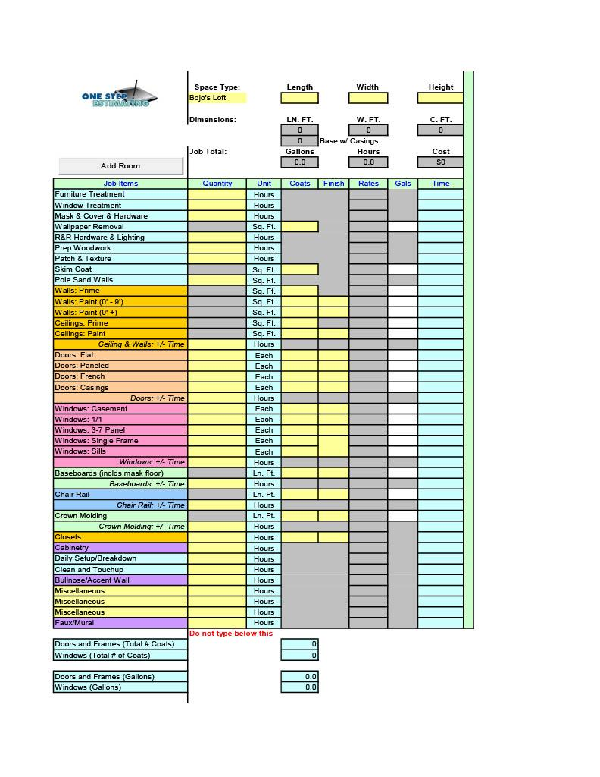

**Review Proposal/Contract Page**

The review proposal and review contract pages will simply be used to review all of the information that has been entered for each room. Although these are technically separate pages, they have the same use case. They are only separate because the full document (Proposal or Contract) should be shown in order to verify it. In this way, the documents could exist on the same page if there were interaction components that toggled between the documents’ preview. The users of this page will mostly be the estimator, but again should be simple enough for a customer to be able to understand. This page also should include the ability for the user to revisit a Room in order to adjust/add/remove details. If the user is happy with all of the entered information they should be ready to send the information to the customer through the click of one final button: “Send to Customer”. This button should generate a pdf of the proposal and a contract. Then, the button should send the pdfs to the email provided by the customer in the General Information Page, as well as to the email of the estimator.

**Header**

There should be a simple and minimal header that is the same on each page. It should include the name of the program: “Karen’s Company Paint Estimator Program” and the Karen’s Company Logo. It should not be distracting.

**Footer**

There should be a very simple footer that is the same on each page. It should include copyright information, Karen’s Company contact information: Phone, email, office address, and the Karen’s Company slogan “Let us color your world!”.

## Dynamic Functionality on the Website:

The majority of the web application is a form that allows users (Karen’s Company employees) to input bid information, use that information to create a proposal, and send that proposal to a customer. Thus, there will be a lot of JavaScript functionality in the majority of the pages. A major goal for the application is to make it easy for Karen’s Company estimators to learn and use the system so I am going to be paying a lot of attention to Daniel Nielson’s 10 Usability Heuristics. The examples provided illustrate multi-step forms that illustrate good examples of how to follow some of these important heuristics.

The first example is the sign-up process for [pinterest.com](https://pinterest.com/). This is a 4-5 step process that I can use as an example that follows many of the usability heuristics well. The form shows the system status at the top to indicate how much of the form they have completed. However, I hope to make the system status even more clear and interactive so that a Karen’s Company estimator can easily move back/forward between steps in the process. The Pinterest form is consistent with the buttons that advance the user to the next step (red background, white font, large & rounded button, at the bottom of the dialog). I plan on using consistent UI and layout elements throughout the *Karen’s Company Paint Estimator Program*. Most importantly, the final Pinterest step is a great example of recognition over recall. I plan to pay a lot of attention to this heuristic and will use a similar design (grid of images with labels) on the “Add a Space Type” step/page. I will include images with labelled room names that users can select to put into the proposal. I plan to implement functionality from my second example which is [cava.com](https://cava.com/)’s online ordering process. Similar to pinterest, cava uses button-images to let the user recognize toppings and overlays the images with the “amount” that the user selected. I plan to use a similar overlay on the button-images that I will present in the “Add a Room” page so that Karen’s Company Employees can clearly select what room types to include on the bid and how many if there are multiple of the same room type. For example, if a customer wants to paint two bedrooms, the form will overlay “2” on the “Bedroom” image-button. When we continue to the checkout step of the Cava process, the UI is clearly minimal and aesthetic. One of the important aspects of the web-application I am designing is that it has a significant amount of conditional logic/data that depends on the types of rooms in the bid. I hope to use Cava’s checkout page as inspiration for the “Size & Details” pages, because of its minimal design, its attention to error prevention, and its familiar language. This will reduce the cognitive load on the “Size & Details” pages and help users navigate the process without missing crucial information.

I have yet to find a good example of how I want to implement the UI for the first step of the Estimator Form (“Customer Information”). This step of the form will naturally have lots of textboxes for names, address, contact information, etc. I know I will have to be intentional about where I apply whitespace and alignment in order to minimize the cognitive load that this step has. It is also important to properly set up the “next input” flow of the form.

**Pinterest Screenshots:**



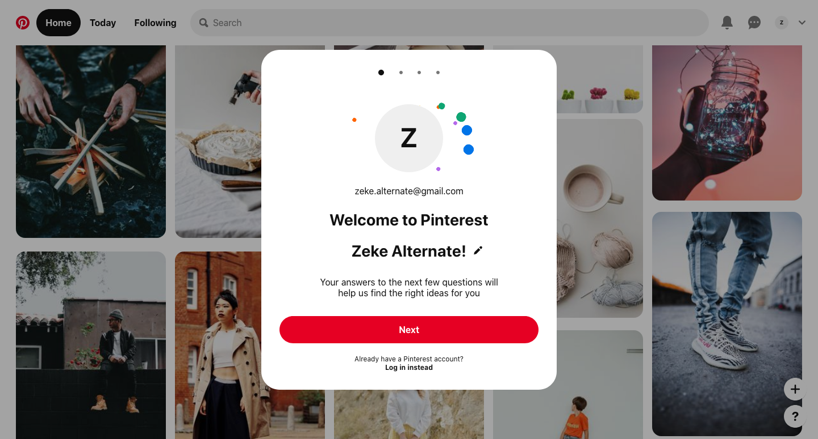

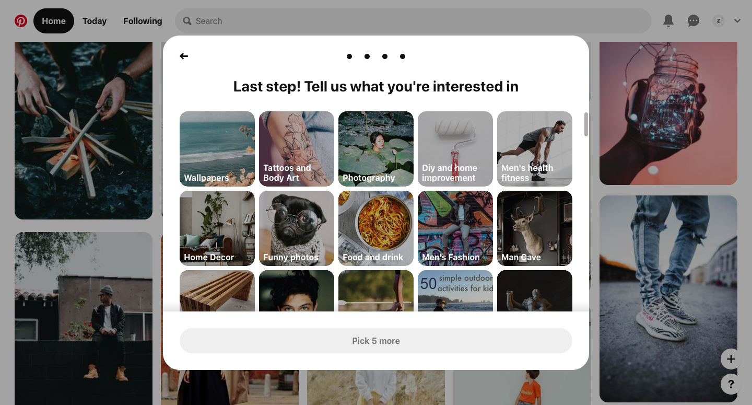

**Cava Screenshots:**

